Open positions
September, 2026

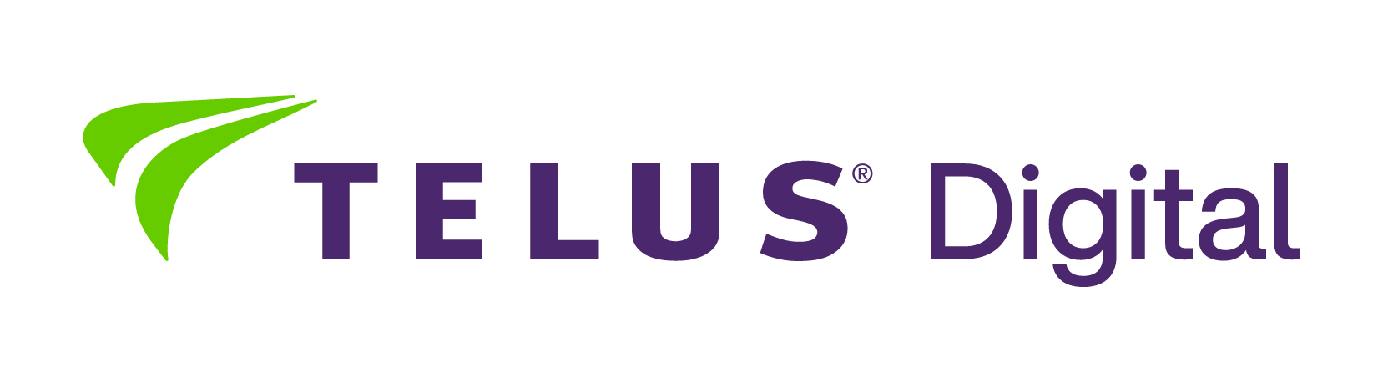
Digital Trust and Safety positions:
- Digital Trust and Safety Specialist with English
- Digital Trust and Safety Specialist with Norwegian and English
- Digital Trust and Safety Specialist with Polish and English
- Digital Trust and Safety Specialist with Dutch and English
- Digital Trust and Safety Specialist with French and English
- Digital Trust and Safety Specialist with Czech and English
- Digital Trust and Safety Specialist with Greek and English
- Digital Trust and Safety Specialist with Turkish and English
- Digital Trust and Safety Analyst with German and English

Gaming positions:,

- Player Support Specialist for Gaming Account with German and English
- Player Support Specialist for a Gaming Account with Polish and English
- Player Support Specialist for Gaming Account with Italian and English
- Player Support Specialist for Gaming Account with French and English
- Player Support Specialist for Gaming Account with Russian and English
- Game Support Representative with Arabic and English
- Trust & Safety Specialist for Supercell Games Account with Russian and English
- Trust & Safety Specialist for Supercell Games Account with Turkish and English
- Player Support Specialist for Supercell Games Account with Arabic and English
- Back Office Gaming Support Specialist with French and English
- Back Office Gaming Support Specialist with German and English

Other:

- Solutions Consultant with Danish and English
- Solutions Consultant with Irish and English
- Solutions Consultant with Slovak and English
- Solutions Consultant with Icelandic and English
- Fitbit Products Support Specialist with Danish and English

Hybrid or remote positions:

- Digital Trust and Safety Analyst with German and English
- Logistics & Delivery Advisor with Dutch and English
- Logistics & Delivery Advisor with French and English
- Travel Support Advisor with German and English - WFA

